**SGM MAGNETICS ENQUIRY FORM**

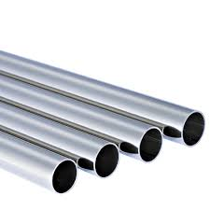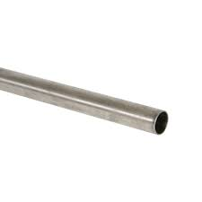

**Single or layer pipes**

**General Information:**

|  |  |  |
| --- | --- | --- |
| Company name |  | |
| Person to contact |  | |
| E-mail address |  | |
| Phone no. |  | |
| Address |  | |
| Your SGM Contact | Name: | Phone no.: |

**Pipe specifications:**

|  |  |  |
| --- | --- | --- |
| Length | Min. mm/inches | Max. mm/inches |
| Outside diameter (OD) | Min. mm /inches | Max. mm/inches |
| Wall thickness (WT) | Min. mm /inches | Max. mm/inches |
| Minimum possible WT that the largest pipe OD may present | Min. kg/lbs |  |
| Maximum possible WT that the largest pipe OD may present | Max. kg/lbs |  |
| Lifting mode | 🞎 Single pipe | 🞎 Layer of pipes |
| Pipe layer composition | Qty. | per OD mm/inches |
| Qty. | per OD mm/inches |
| Qty. | per OD mm/inches |
| **The pipes are:** | | |
| 🞎 Seamless | | |
| 🞎 Spiral welded, thickness mm/inches | | |
| 🞎 Longitudinal weld, thickness mm/inches | | |
| Temperature | 🞎 Ambient | 🞎 Hot (>150°C/300°F) |
| **For hot pipes only** | | |
| Standard surface temperature °C/°F | | |
| Maximum surface temperature °C/°F | | |

**Crane specifications:**

|  |  |  |
| --- | --- | --- |
| Crane rated voltage | 🞎 Vac 🞎 Vdc |  |
| Crane working environment | 🞎 Indoor 🞎 Outdoor |  |
| **Crane type and capacity** |  |  |
| 🞎 Single hoist | 🞎Two hoists (set distance) | 🞎Two independent hoists |



|  |  |  |
| --- | --- | --- |
| Capacity tons | Capacity 1 tons | Capacity 1 tons |
|  | Capacity 2 tons | Capacity 2 tons |
|  | Set distance  mm/inches |  |

**Remarks:**

|  |  |  |  |
| --- | --- | --- | --- |
| **Preferred solution:** | | | |
| 🞎 Electro-magnet | | | |
| 🞎 Electro-permanent magnet | | | |
| 🞎 No preference | | | |
| **For Electro-magnet only** | | | |
| Battery back-up requested: | 🞎 Lead Acid Type | 🞎 Gel Type | 🞎 Not requested |
| Battery back-up duration: | 🞎 20 minutes | 🞎 30 minutes | 🞎 Other |

**Notes**:

|  |
| --- |
|  |