**SGM MAGNETICS ENQUIRY FORM**

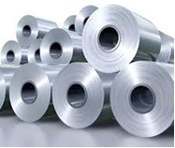

**Horizontal eye coils**

**General Information:**

|  |  |  |
| --- | --- | --- |
| Company name |  | |
| Person to contact |  | |
| E-mail address |  | |
| Phone no. |  | |
| Address |  | |
| Your SGM Contact | Name: | Phone no.: |

**Coil specifications:**

|  |  |  |
| --- | --- | --- |
| Inner diameter | Min. mm/inches | Max. mm/inches |
| Outer diameter | Min. mm/inches | Max. mm/inches |
| Width | Min. mm/inches | Max. mm/inches |
| Weight | Min. tons/US tons | Max. tons/US tons |
| Smallest coil OD presenting the maximum weight | mm/inches |  |
| Steel gauge | Min. mm/inches | Max. mm/inches |
| Are coils zinc coated? | 🞎 No | 🞎 Yes, thickness micron |
| Temperature | 🞎 Ambient | 🞎 Hot (>150 °C / 300 °F) |
| **For hot coils only** | | |
| Standard surface temperature °C/°F | | |
| Maximum surface temperature °C/°F | | |
| Standard time per magnet lifting cycle seconds | | |
| Standard quantity of lifts per hour | | |
| Maximum lifts per hour | | |
| Are there any stops in operation? 🞎 No 🞎 Yes, every time for time | | |
| **Slit coils**: 🞎 No 🞎 Yes | | |

**Notes**:

|  |
| --- |
|  |

**Coil wrapping specifications:**

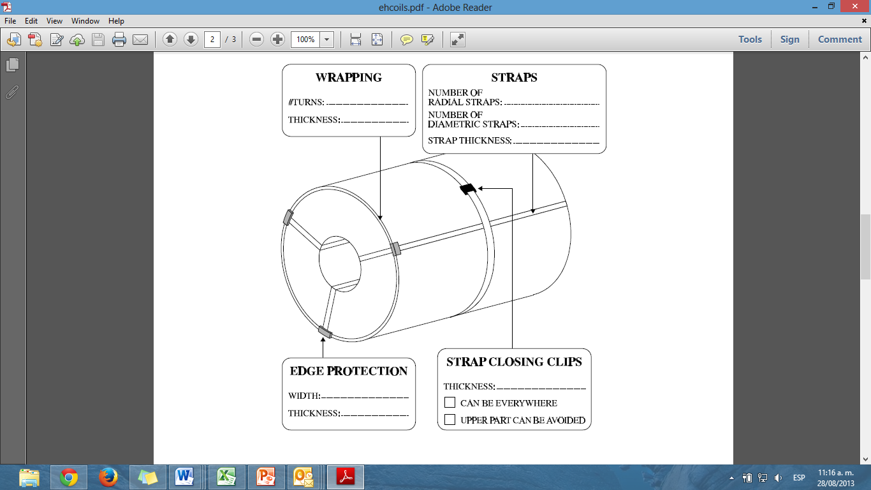

**Crane specifications:**

|  |  |
| --- | --- |
| Crane capacity tons/US tons | |
| Crane rated voltage | 🞎 Vac 🞎 Vdc |
| Crane working environment | 🞎 Indoor 🞎 Outdoor |

**Remarks**:

|  |  |  |  |
| --- | --- | --- | --- |
| **Preferred solution:** | | | |
| 🞎 Electro-magnet | | | |
| 🞎 Electro-permanent magnet | | | |
| 🞎 No preference | | | |
| **For Electro-magnet only** | | | |
| Battery back-up requested: | 🞎 Lead Acid Type | 🞎 Gel Type | 🞎 Not requested |
| Battery back-up duration: | 🞎 20 minutes | 🞎 30 minutes | 🞎 Other |
| **Process stage:** | | | |
| 🞎 Hot rolled | | | |
| 🞎 Cold rolled | | | |
| 🞎 Shipping bay | | | |
| 🞎 Else | | | |