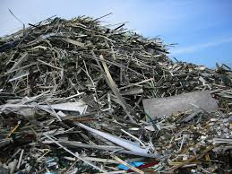

Scrap Handling

General Information:
Company name
Person to contact
E-mail address
Phone no.
Address
Your SGM Contact | Name: | Phone no.:

Scrap mix specifications:
Average Data
Scrap density tons/m³ (Us tons/ft³)
Magnet tonnage requirement per pick tons
Magnet tonnage requirement per hour or shift

Detailed Data
Scrap Specification | % | Density  (tons/m³ - Us tons/ft³) | Tonnage requirement  per pick

Magnet Working Cycle:
Time per magnet picking cycle seconds
Magnet electrical duty cycle %
Magnet shall operate hrs/day for days/week

Crane specifications:
Crane rated voltage | ◻ Vac ◻ Vdc
Crane working environment | ◻ Indoor ◻ Outdoor

Preferences:
Magnet size (diameter) | mm/inches
Magnet weight | kg/lbs.
Rated power | kW

Remarks:
For Electro-magnet
Battery back-up requested: | ◻ Lead Acid Type | ◻ Gel Type | ◻ Not requested
Battery back-up duration: | ◻ 20 minutes | ◻ 30 minutes | ◻ Other

Notes:

