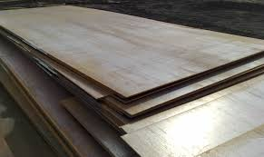
Plates

General Information:
Company name
Person to contact
E-mail address
Phone no.
Address
Your SGM Contact | Name: | Phone no.:

Plate specifications:
Length | Min. mm/inches | Max. mm/inches
Width | Min. mm/inches | Max. mm/inches
Thickness | Min. mm/inches | Max. mm/inches
Minimum thickness of the largest plate | mm/inches
Maximum thickness of the shortest plate | mm/inches
Maximum plate weight | Kg/lbs
Temperature | ◻ Ambient | ◻ Hot (>150°C/300°F)

Application:
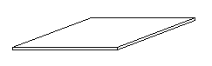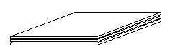
◻ Always single plate
◻ Multiple loose plates

Typical quantity of plates per thickness
quantity: x plate thickness mm/inches
quantity: x plate thickness mm/inches
quantity: x plate thickness mm/inches
quantity: x plate thickness mm/inches
◻ as many as possible

Notes:

EMBED MSPhotoEd.3 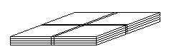
◻ Banded plate packs

Pack size
Length | Min. mm/inches | Max. mm/inches
Width | Min. mm/inches | Max. mm/inches
Height | Min. mm/inches | Max. mm/inches
Weight | Min. kg/lbs | Max. kg/lbs
Typical banding
Quantity per length
Quantity per width
Band thickness mm/inches
Band clip: Location: ◻ Top ◻Side | Thickness mm/inches

Crane specifications:
Crane rated voltage | ◻ Vac ◻ Vdc
Crane working environment | ◻ Indoor ◻ Outdoor
Crane type and capacity
◻ Single hoist | ◻Two hoists (set distance) | ◻Two independent hoists

Capacity tons | Capacity 1 tons | Capacity 1 tons
 | Capacity 2 tons | Capacity 2 tons
Set distance
mm/inches

Remarks:
Preferred solution:
◻ Electro-magnet
◻ Electro-permanent magnet (only for single plate lifting)
◻ No preference
For Electro-magnet only
Battery back-up requested: |  | ◻ Lead Acid Type |  | ◻ Gel Type |  | ◻ Not requested
Battery back-up duration: |  | ◻ 20 minutes |  | ◻ 30 minutes |  | ◻ Other
Lifting area environment:
◻ From cooling bed | ◻ Billet yard |  | ◻ Truck loading |  | ◻ Else, please specify

