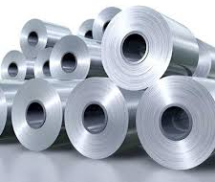

Horizontal eye coils

General Information:
Company name
Person to contact
E-mail address
Phone no.
Address
Your SGM Contact | Name: | Phone no.:

Coil specifications:
Inner diameter | Min. mm/inches | Max. mm/inches
Outer diameter | Min. mm/inches | Max. mm/inches
Width | Min. mm/inches | Max. mm/inches
Weight | Min. tons/US tons | Max. tons/US tons
Smallest coil OD presenting the maximum weight | mm/inches
Steel gauge | Min. mm/inches | Max. mm/inches
Are coils zinc coated? | ◻ No | ◻ Yes, thickness micron
Temperature | ◻ Ambient | ◻ Hot (>150 °C / 300 °F)
For hot coils only
Standard surface temperature °C/°F
Maximum surface temperature °C/°F
Standard time per magnet lifting cycle seconds
Standard quantity of lifts per hour
Maximum lifts per hour
Are there any stops in operation? ◻ No ◻ Yes, every time for time
Slit coils: ◻ No ◻ Yes

Notes:
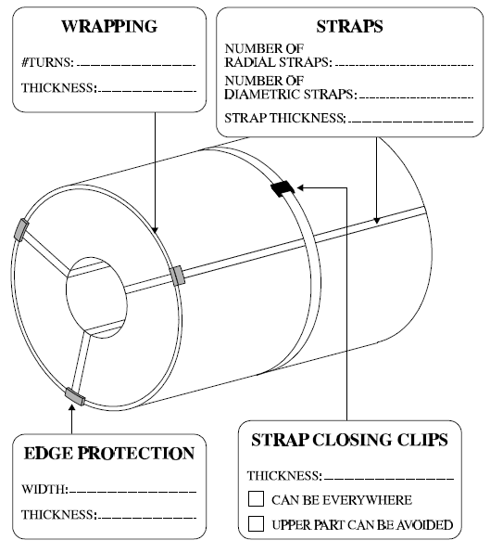
Coil wrapping specification:

Crane specifications:
Crane capacity tons/US tons
Crane rated voltage | ◻ Vac ◻ Vdc
Crane working environment | ◻ Indoor ◻ Outdoor

Remarks:
Preferred solution:
◻ Electro-magnet
◻ Electro-permanent magnet
◻ No preference
For Electro-magnet only
Battery back-up requested: | ◻ Lead Acid Type | ◻ Gel Type | ◻ Not requested
Battery back-up duration: | ◻ 20 minutes | ◻ 30 minutes | ◻ Other
Process stage:
◻ Hot rolled
◻ Cold rolled
◻ Shipping bay
◻ Else

